EIOPA-CAT_WS-17/004
SCR review project - Information request on the calibration of the natural CAT risk sub-module
The national associations of insurers who have answered the information requirement belong to the following countries:
- Finland
- Greece
- Slovenia
- Slovakia
- Spain
- United Kingdom
- Germany
- Italy
- Sweden
Data input collected is related to the following risks:
Windstorm | Earthquake | Flood | Hail
Spain  Germany  Slovenia  Finland  Sweden | Greece  Slovakia  Italy | Germany | Germany  Slovenia
(*) UK provides general comments without contributing survey information to any specific risks

In order to facilitate the analysis, some statistical measures and ratios have been calculated based on the survey information for country.

INFORMATION REQUEST
- Survey information:

(a.1) Survey for the country

Windstorm
- Spain provides information based on 8 events from 2005 to 2014. In 6 events of 8, data represents around 80% of the whole market. Data of the other 2 events represents around 13% of the whole market. The data is shown net of CCS in this report.

- Germany provides information based on 13 events from 2002 to 2014. Data represents nearly 100% of the total motor market and a major part of the total property market.

- Slovenia provides information regarding hail and windstorm, and establishes in its document that “in the case of loss events with occurrence of hail and windstorm some insurance companies attributed all losses to one risk”.
Windstorm data is based on 12 events from 2006 to 2016. No market share and SCR amounts are reported.

- Finland provides information based on 16 events from 2001 to 2016. For the years 2010-2016 (10 events), data is from all the participating companies (5 companies out of 7 companies, one of the outsiders is very new company, and the other is not the member of Federation of Finnish Financial Services), and before that there are only numbers from some of them but market share is not reported.

- Sweden provides information based on one event in 2005 (Gudrun). Five undertakings which represents 83% of whole market, have contributed to the data collection.

It is not possible to obtain measures or ratios based on the information provided.

Earthquake
- Greece provides information, which is split into two groups, on one hand, related to one company (company A), and on the other hand, related to the rest of the market. Data is based on two events in 1999 and 2014.
Data corresponding to the specific company is complete but part of the information regarding the rest of the market is missing.

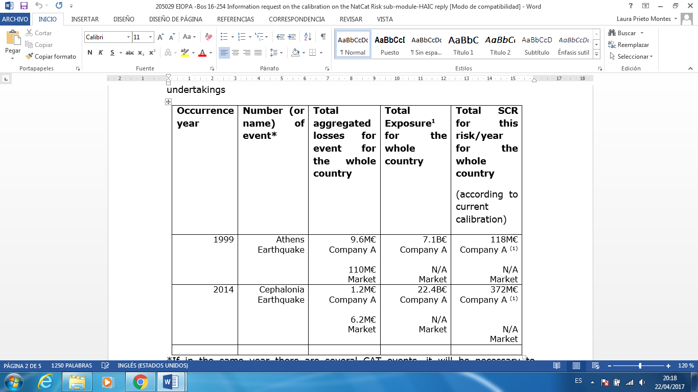

It is not possible to obtain measures or ratios based on the information provided.

- Slovakia answers that it didn’t register any significant claim related to earthquake during last 15 years (several registered claims where less than 10.000€, mostly less than 1000€). It provides CAT data regarding 2016 which is based on 87% of the whole market, as example:

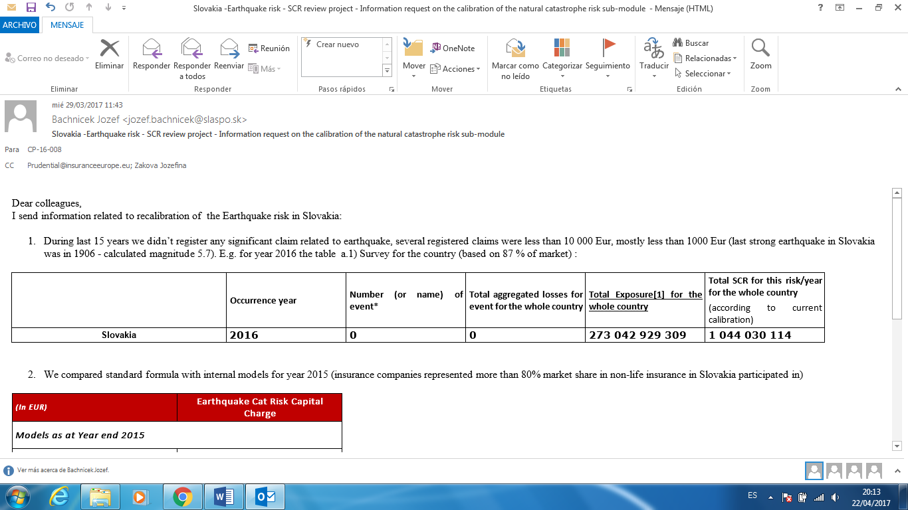

It is not possible to obtain measures or ratios based on the information provided.

- Italy provides information based on 8 events from 2009 to 2016. No market share is reported.

Flood
- Germany provides information based on 16 events from 2002 to 2013. Data from property represents more than 90% of the whole market.

Hail
- Germany provides information based on 22 events from 2001 to 2014. Data from property represents more than 90% of the total market related to motor and property.

- Slovenia provides information regarding hail and windstorm, and establishes in its document that “in the case of loss events with occurrence of hail and windstorm some insurance companies attributed all losses to one risk”.
Hail data is based on 19 events from 2006 to 2016. No market share and SCR amounts are reporting.

(a.2) Survey per zone

- Spain provides information per zone regarding 8 windstorm events previously mentioned.
- Germany doesn’t provide data per zone.
- Information provided by Greece is not complete both for the specific company and for the rest of the market.
- Slovenia provides hail and windstorm data per zone, but no market share and SCR amounts are reported.
- Finland doesn’t provide data per zone.
- Italy provides information per zone regarding 8 earthquake events previously mentioned, but no market share is reported.
- Sweden provides information per zone regarding the windstorm Gudrun (1 event). Five insurance undertakings which represents 50% of the total market, has submitted the related data.

- Other quantitative and qualitative information:
- Vendor and Internal models:
  - RQE, RMS and AIR for earthquake risk in Italy and in Germany for windstorm risk.
  - Regarding Italian earthquake submodule, the results of evaluations carried out by the internal model (RQE) or by specialized key third party software providers (RMS, AIR) points to a heavy miscalibration in the risk calculation amounting to approx. a 270% difference between the STDF and the internal model results gross of reinsurance (based on 2015 data of the 80% market share).
  - Slovakia concludes that the amount of the SCR SF is 179.43% higher than partial internal model in earthquake submodule.
  - Germany establishes that vendor and internal models generally result in lower SCR for windstorm risk than the standard formula.
  - Greece shows in its documentation that based on a preliminary study survey performed in 2014 among 15 Greek insurance undertakings, representing 76.5% of the total market share of the fire branch (based on data of 2013), it appeared that for more than 33% of respondents the SF for EQ risk produced outputs which were at least 20% higher compared to the outputs of the models they used at the time the survey was performed. For more than 66% of respondents, the SF produced results at least 10% higher than the outputs of the models they used at the time the survey was performed.
  - UK shows the over-calibration of the SF through an example, which is explained as follows: “one member firm has compared the 100% windstorm loss generated by the Standard Formula to the 1 in 200 year return output from four commercially available windstorm models (all using the firm’s own risk exposure data). The Standard Formula loss is over 13% higher than the loss from the highest calibrated model, and over 32% higher than the average loss of the four models.”

- Other information:
  - Spain points out that in major events the CCS (Consorcio de Compensación de Seguros) assumes much share of the total impact (vehicles, railway vehicles and other damages to goods). CCS is forced by law to cover windstorm risk (atypical cyclones) where the speed of wind upper 120 km/h. The data is shown net of CCS in this report.
  - Germany stablishes that risk factors of adjacent zones differ considerably, which does not seem to reflect properly the related natural risk.
  - Germany considers that flood risk is significantly overestimated and hail is rather underestimated for MNTPL (flood is not a relevant risk but hail is for many Germany undertakings).
  - Greece suggests to include new parameters or factors (for example, type and year of construction of insured buildings to take into account the increasing anti-seismic construction) in the calculation of SF for earthquake risk.
  - UK considers the calibration of the natural catastrophe risk component of the Standard Formula is too conservative.
  - Italy points out that the calibration of the Standard Formula Italian Earthquake submodule does not adequately account for the effective impact of contractual policy conditions (indemnity limits and deductibles) that need to be taken into consideration to adequately assess the Italian insurers' exposure to earthquake risk. Evidence shows that the average contractual limit in the Italian portfolio is less than 30% of the sums insured.
  - Italy explains that in certain cases until 09-2016 the flood and earthquake risk has derived from a particular collective insurance productsell in 2008-2009 (currently in run-off) that provide with a maximum indemnity of 2,5 mln € that has to be proportionally distributed for all the exposures when a claim occurs. For this reason gross risk capital was the amount Italian undertakings have to pay in case of claim occurrence. The amount is calculated as min(2,5 mnl; standard formula result).
  - The Italian document establishes that the calibration of the Standard Formula Italian Flood submodule does not adequately account for the effective impact of contractual policy conditions (indemnity limits and deductibles) in the Italian flood risk portfolio. As for earthquake risk, the average contractual limit in the Italian portfolio is less than 25% of the sums insured.
  - Italy suggests that, on one hand, the hail risk capital requirement should not be the same for building and content coverages, and on the other hand, the flood risk capital requirement should not be the same, for example, for exposure on the ground floor and upper floors of a building.
  - Sweden proposes to recalibrate all the risk weights for the zones and the mapping to counties be clearly stated. It is based on the following explanation: “the reason for this is that the risk weighs are not in line with their experience. Moreover, the provisions of the Solvency II regulation (Delegated Acts), Annex IX are ambiguous”.

