EIOPA CAT Workstream - Fire risk submodule
July 2017
- Introduction
The EIOPA Catastrophe Workstream (CAT WS) has been mandated to develop an alternative calculation for the fire risk submodule.
There are two aspects to the review of the submodule, the simplification of the volume measure and the calibration of the submodule. This paper assesses only the issue of simplification.
In addition, the topic of identification of largest exposure gross or net of reinsurance is being assessed separately and an information request regarding this is being undertaken.
- Existing calculations
Article 132 of the Delegated Regulation provides the existing specifications for the calculation of the fire risk SCR. In summary, the current capital requirement for fire risk is equal to the maximum amount of an (re)insurer’s exposure (measured as sum insured) within any 200m radius,
A number of different methods were considered during the design of the submodule. The existing methodology was chosen primarily because it provides a sense of risk concentration, which is a key aspect of fire, explosion and terror risk factors. The 200m radius was calibrated based on expert judgement and loss statistics.
Feedback provided in response to the questions on fire risk in the Discussion Paper on Solvency II Review showed that many undertakings found it difficult to assess the value of exposure within any 200m radius. It was also noted that the calibration of the submodule was deemed to be overly conservative by some.
Further investigation by the CAT WS members (Insurance Europe) suggests that difficulties and cost in assessing the value of the exposure can arise from the following:
- Technology to automate the 200m calculation based on a geocoded portfolio can be expensive, unavailable or lack accuracy
- Undertakings are manually assessing the exposure
- Large amount of data cleansing/validation required due to;
  - Inconsistencies between underwriting process and fire risk submodule calculations
  - Incorrect data collection
  - Changes or additions to address/postcodes
In addition, feedback was also provided on the use of Possible Maximum Loss and/or Estimated Maximum Loss measure instead of sum insured. However, the use of these measures is not within the scope of the CAT WS and have not been considered as part of this document.
- Principles against which simplifications were assessed
The CAT WS members discussed the feedback and categorised the issues into three areas; the geocoding of exposures, the identification of the largest exposure concentration and data issues.
The following summarises the CAT WS members’ discussion on each of these topics.
Geocoding of exposures
Geocoding is a requirement of the existing methodology. It is a necessary step to properly assess risk concentration.
The broad consensus on the CAT WS was that the existing approach provided good risk sensitivity and that any change in approach or simplification of the fire risk submodule should not depart from the assessment of risk concentration as a core principle.
Identification of largest exposure concentration
The existing methodology requires undertakings to identify the 200m radius circle with the greatest concentration of exposure (maximum probable loss for total sum insured).
The CAT WS members accepted that specialist software was required scan every possible 200m radius circle to achieve this accurately. It is understood that several software providers offer this type of software, although the extent of coverage across the EEA is not clear.
As well as the availability of this software, its cost was also prohibitive to its use, especially for small and medium sized undertakings. It was therefore agreed that any changes should continue to encourage proper data recording and management.
Data issues
It was recognised that there may be data issues which were causing issues. The CAT WS members broadly agreed that undertakings should be incentivised to improve data recording and understanding of their risks.
Given the issues raised above and feedback from CAT WS members, the CAT WS assessed the proposals against the following key criteria.
- Risk sensitivity – there should be very limited loss in overall levels of risk sensitivity.
- Simplicity – the calculations should be straightforward to understand and implement.
- Usability - any new calculations should be easily adopted by undertakings, both in terms of cost and resource.

- Alternative calculations
The following proposals, sourced mainly from the responses to the Discussion Paper, were considered by the CAT WS.
More detail on each proposal, an assessment against the above criteria and an impact assessment are set out in the following sections.
- Retain existing volume measure ie no change to current calculation.
- Using the largest exposure measure with an adjustment for conflagration.
- Using the simplification of QIS 5 (a factor based approach).
- Alter the formula to reflect market share, building density and reconstruction costs.
- Limit the scope of the identification to the largest concentration of risk within a 200m radius circle to, at a minimum, the top five exposures per risk type (industrial, commercial, residential).

  - Retain existing volume measure ie no change
    - Description
No change is made to the existing modelling approach (although a calibration of the radius could be considered separately).
    - Discussion
The advantages of this approach include:
- The current level of risk sensitivity is maintained.
- The concept’s simplicity is retained.
- Improvements in IT systems/programs could reasonably be expected to be developed over the coming years to enable most undertakings to model the risk.
- It would encourage improved data recording.
- Under this methodology, the fire risk submodule is classified as risk catastrophe event within the EIOPA Guidelines on Application of Outwards Reinsurance.
The disadvantages of this approach include:
- There are some exposures which are still likely to be burdensome for undertakings to geocode.
- Different simplifications may continue to be adopted by undertakings reducing consistency across undertakings.
- The cost may continue to be burdensome for small and medium sized undertakings.
This option is neither a simplification nor an alternative calculation. However, the CAT WS members agreed with the conclusions from the previous CAT taskforce that this is the optimal approach.
  - Using the largest exposure measure with an adjustment for conflagration
    - Description
The volume measure is altered to be the undertaking’s largest exposure with an adjustment made to reflect the possibility of conflagration.
The conflagration adjustment could be simply be a fixed factor eg
SCR_{fire} = (1+X) · SI_{largest_exposure.}
Where SI_{largest_exposure} = undertaking’s largest exposure
X = a factor (to be calibrated)

Alternatively, it could be based upon the undertaking‘s specific portfolio eg
SCR_{fire} = SI_{largest_exposure} + α_{I} · Expo_Ptf
Where SI_{largest_exposure} = undertaking’s largest exposure
Expo_Ptf = undertaking’s total exposure, excluding the largest exposure, in the postal code area where SI_{largest_exposure} is located
α_{i} = factor to represent damage rate in postal code i

It was proposed to have three damage rate factors (α_{1,} α_{2 and} α₃) which would broadly be representative of building density.

    - Discussion
The advantages of this approach include:
- Largest single exposure is easily identifiable
- Using a fixed factor as an adjustment would make the calculation very straightforward
- Expected to be low cost and easy to implement
The disadvantages of this approach include
- There is a loss of risk sensitivity
- Removal of the requirement to geocode arguably reduces the incentive for undertakings to fully understand their risks.
- Calibration of the conflagration adjustment would likely prove difficult:
  - A simple factor-based adjustment is difficult to justify given the differing portfolio compositions across Europe.
  - A more complex approach reflecting building density in different postcodes is likely to be burdensome to calibrate and may still be theoretically difficult to justify. The use of postal codes may not be appropriate for every jurisdiction.
The CAT WS believe that this proposal satisfies the simplicity and usability criteria. However, there is substantial loss of risk sensitivity which the CAT WS considered to be the primary drawback of the proposal. In addition, there are a number of practical limitations with the proposal, including the calibration of the conflagration adjustment factors and the potential use of postal codes.
  - Using the simplification of QIS 5 (factor based approach)
    - Description
This approach separates the undertaking’s exposure into three subcategories (residential, commercial and industrial). The total value of exposure in each subcategory is multiplied by a factor and summed. The SCR_{fire} is then set as the maximum of this value or the largest sum insured eg
SCR_{fire} = max (SI_{largest_exposure,} $\sum_{x}{SIx ·Fx}$)
Where
SI_{largest_exposure} = undertaking’s largest exposure (across all subcategories)
SI_{x} = sum insured across subcategory x
F_{x} = market wide risk factors
X = Residential, Commercial and Industrial
The factors, F_{x}, used in QIS5 are as follows:
Residential 0.004%
Commercial 0.010%
Industrial 0.073%
    - Discussion
The advantages of this approach include
- Increased usability as factor-based approaches are easy to apply.
- Reduced calculation burden as requirement to identify concentration risk is removed.
- Minimal implementation costs are expected.
- The largest sum insured underpin ensures a minimum capital requirement which is realistic (albeit arguably on the low-side ie if the underpin bites then there is no explicit capital requirement for the risk of conflagration).
The disadvantages of this approach include
- Loss of risk sensitivity.
- Removal of the requirement to geocode arguably reduces the incentive for undertakings to fully understand their risks.
- Categorisation of exposures can be subjective in some cases.
- Recalibration of the factors would be required.
- Difficult to justify the calibration of factors result in a level of capital which is consistent with the aim of Solvency II.
This approach provides an alternative methodology which departs significantly from the existing calculation in terms of risk sensitivity. It does, however, provide a simple and useable calculation which could be expected to be implemented uniformly across all jurisdictions.
The CAT WS members considered the loss of risk sensitivity arising from the implementation of this approach to be the primary drawback.
  - Alter the formula to reflect market share, building density and reconstruction costs
    - Description
Another proposal put forward in response to the Discussion Paper suggests adopting a model which includes market share, building density and reconstruction costs and would be calculated as follows.
SCR_{fire} = %MS · %DS · R² · NF · €/m²
Where
MS = market share of premiums of the undertaking
DS = density of buildings in circle area
R = radius of a circle
NF = average number of floors per building
€/m² = average cost of reconstruction

    - Discussion
The advantages of this approach include
- Reduced calculation burden as requirement to identify concentration risk is removed.
The disadvantages of this approach include
- Loss of risk sensitivity as the calculation averages an entire region
- Removal of the requirement to geocode arguably reduces the incentive for undertakings to fully understand their risks.
- Loss of simplicity through increased data requirements (cost of reconstruction, average number of floors etc.)
- The circle size would need to be calibrated
- Parameters would need to be updated regularly (average cost of reconstruction, market share of premiums).
The CAT WS members do not consider this proposal to satisfy the key criteria against which the proposals are being assessed. It was noted that this may provide a useful simplification for specific undertakings but that there were a number of aspects which inhibit its usefulness more widely. In particular, the data requirements such as the density of buildings in the circle area and the determination of the average cost of reconstruction.
  - Limit the scope of the identification to the largest concentration of risk within a 200m radius circle to, at a minimum, the top five exposures per risk type (industrial, commercial, residential).

    - Description
This approach is theoretically consistent with the existing approach but restricts the calculation requirements to the 200m radius around the largest five exposures, per risk type, in the portfolio ie it assumes that the largest concentration of exposure within any 200m radius will have one of the largest five exposures, per risk type, as a central point.
To counteract any unjustified reduction in the risk sensitivity for portfolios where there are no significant single exposures (eg portfolios of residential policies), an underpin is also proposed.
The resulting formula would be SCR_{fire} = max (SCR_{firei}, SCR_{firec}, SCR_{firer})
Where
SCR_{firei} = max(E_{1i}, E_{2i}, E_{3i}, E_{4i}, E_{5i})
SCR_{firec} = max(E_{1c}, E_{2c}, E_{3c}, E_{4c}, E_{5c})
SCR_{firer} = max(Θ ,E_{1r}, E_{2r}, E_{3r}, E_{4r}, E_{5r})
E_{xi} = Total exposure (building, content and business interruption) within 200m radius of xth largest industrial exposure.
E_{xc} = Total exposure (building, content and business interruption) within 200m radius of xth largest commercial exposure.
E_{xr} = Total exposure (building, content and business interruption) within 200m radius of xth largest residential exposure.

Θ = Underpin factor (to be calibrated)
The underpin formula could look like: average sum insured of portfolio residential exposure X affected number of homes (tbd) X residential M/S of undertaking.
It is however clear that the calibration of the underpin will be extremely challenging or not achievable within timeframe.
In such case, I am inclined to propose the option to remove the underpin under the argument that for an homogeneous portfolio, selecting all exposure within 200m around the top 5 exposures is likely to provide a fair representation of a conflagration risk which remains quite hypothetical for residential. Noting that whatever standard method is chosen, it would be impossible to know exactly whether an industrial risk lies near these houses or not.
As an alternative to the underpin, it could be mentioned that for portfolios with no significant single exposures, the following simple formula is used (as for other portfolios) SCR fire = max (E1, E2, E3, E4, E5) but (as per ORSA) justification has to be provided as to why this is representative of their conflagration risk.
- In comparison, the existing formula does not provide this risk sensitivity for portfolio with no significant exposures, so we are not reducing risk sensitivity in comparison to the existing method by doing this.

    - Discussion
The advantages of this approach include
- Reduced calculation burden to identify largest concentration of risks for undertakings who are manually assessing their exposures.
- Current level of risk sensitivity will be maintained in majority of cases, especially for undertakings with large (eg industrial) exposures.
- Theoretical integrity of calculation is maintained.
- It provides a consistent and transparent approach for simplification of existing methodology.
- Under this methodology, the fire risk submodule is classified as risk catastrophe event within the EIOPA Guidelines on Application of Outwards Reinsurance.
The disadvantages of this approach include
- Portfolios can be envisaged where there is a loss of risk sensitivity.

Following discussion and feedback, a number of aspects of the calculation have been designed to result in a sufficient level of risk sensitivity:
- The assessment of the five largest exposures, for each risk type, is intended to capture the scenario where clusters of commercial or residential portfolios result in a greater concentration of exposure than higher value, but more isolated, industrial exposures.
- The underpin is designed to provide a minimum level of capital for portfolios of residential properties where the largest risks are less likely to provide the proxy for concentration.
The CAT WS discussed other changes that could be made to the proposal to further increase the level of risk sensitivity.
- Make it a requirement for the five circles being assessed per risk type to be mutually exclusive. This is intended to improve the assessment of concentration in portfolios where multiple contracts are written to the same address. For example, where an undertaking has multiple exposures to the same industrial site.
- Increase the assessment of the concentrations so that the 200m radius circle was required to contain the largest risks rather than have it as a central point.
The CAT WS members recognised the improved risk sensitivity that these alterations would bring. However, it was agreed that a balance needed to be struck between simplicity and risk sensitivity. It was also noted that undertakings needed to provide a qualitative assessment of the simplification through their ORSA process. It was therefore proposed not to incorporate these proposals.
Overall, the CAT WS members considered this proposal to satisfy the criteria against which it is being assessed.
- Calculation of exposure on a gross or net basis
The current volume measure for fire risk is calculated on a gross of reinsurance basis whereas the actual capital requirement is determined net of reinsurance. This can lead to a loss in risk sensitivity if there is a discrepancy between the largest exposure on gross and net basis.
The advantage provided by the simplification of screening a selected number of top exposures allows to implement a more risk sensitive approach by providing fire risk accumulation on a net of reinsurance basis.
An example which explains the issue can be found in section 8.3 of the discussion paper on the Solvency II review.
As noted in the discussion paper, this issue also affects the marine risk and aviation risk submodules. It is assumed consistency of approach is required across all of these submodules.
- Conclusions and recommendations
The mandate of the CAT WS is to provide an alternative calculation for the fire risk submodule. Having reviewed the work of the previous CAT Taskforce and the proposals which were put forward in response to the EIOPA Discussion Paper on Solvency II Review, the CAT WS believes that the existing methodology is the optimal approach and recommends that this remains the default calculation.
However, it is also recognised that there are a number of issues with the current methodology which mean that it is costly or burdensome to implement for all undertakings. The CAT WS therefore recommends that a simplified calculation should be made available.
The CAT WS believes it is important for undertakings to understand their exposures and risks. Likewise, improved data recording and management should be incentivised. The CAT WS therefore believes that the simplification should focus on reducing the calculation burden of the identification of the largest concentration risk. It recommends that proposal 5, limit the scope of the identification to the largest concentration of risk within a 200m radius circle around, at a minimum, the top five exposures per risk type (Industrial, commercial, residential) be adopted as a simplification.
In line with Article 88 of the Delegated Regulation, the application of a simplification requires undertakings to “determine whether the simplified calculation is proportionate to the nature, scale and complexity of the risks.”
As part of their consideration of the proposal as a simplified calculation, the CAT WS members discussed the possible error that would be introduced as a result of the use of the simplified calculation. It was agreed that they do not consider there to be sufficient loss of risk sensitivity through the use of the proposed simplification for a margin of prudence to be required.
Undertakings who use of the simplification will also be required to make an assessment of the risk and document this in the ORSA. The CAT WS members believe that this qualitative assessment of the risk would provide the opportunity to request justification and explanation for the use of the simplification.

Appendix – Examples of historical conflagration events

Conflagration events such as the Enschede and the AZF explosions can serve as a proxy for accumulation events (conflagration) the Fire risk submodule aims at capturing.

Explosion of a fireworks warehouse
Enschede, the Netherlands (2000)
The houses and other structures were razed within a 250-m radius around the site. Over the zone extending out to 750 m, buildings were heavily damaged. In all, 500 homes or businesses were destroyed or sustained considerable damage; the accident had rendered this zone unsafe for any human residence or activity.
The municipality of Enschede decided to evacuate and demolish whatever was still standing. For the time being, the district was considered to no longer exist.

The above description of the disaster consequences conclude to total losses within a 250 meter radius.
Disaster Area
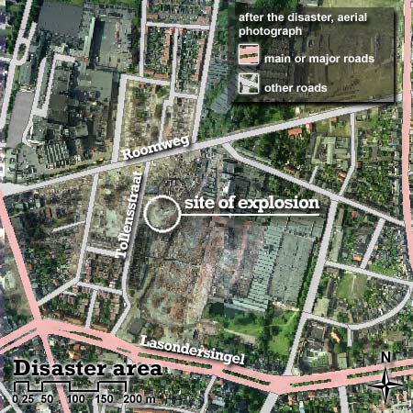
Source: French Sustainable Development Ministry - DGPR / SRT / BARPI

Explosion of the AZF chemical plant
Toulouse, France (2001)
Translated version of French language study: the explosion caused significant damages in the south west part of Toulouse. The AZF industrial site has been obliterated. Only the guard post and the AZF tower remained standing. The guard post was destroyed the following day for security reasons. Nearby, the retail areas of Darty and Brossette were totally destroyed. 150 SEMVAT buses (the Toulouse public transport company) have also been destroyed within the warehouse located in front of the AZF site.
Numerous houses/multi-storey housing, a number of companies and some public equipment (swimming pool, sport hall, concert hall, and a high school) have been damaged. Damages such as cracked walls, blown out doors and windows, ripped out roofs, broken windows, etc. were observed up to downtown Toulouse (a few km away).
This description in addition to the below map shows that exposures numbered 1 to 8 have been totally destroyed by the explosion over a radius going beyond 200 meters. Significant or partial damage area extend well beyond a kilometer.
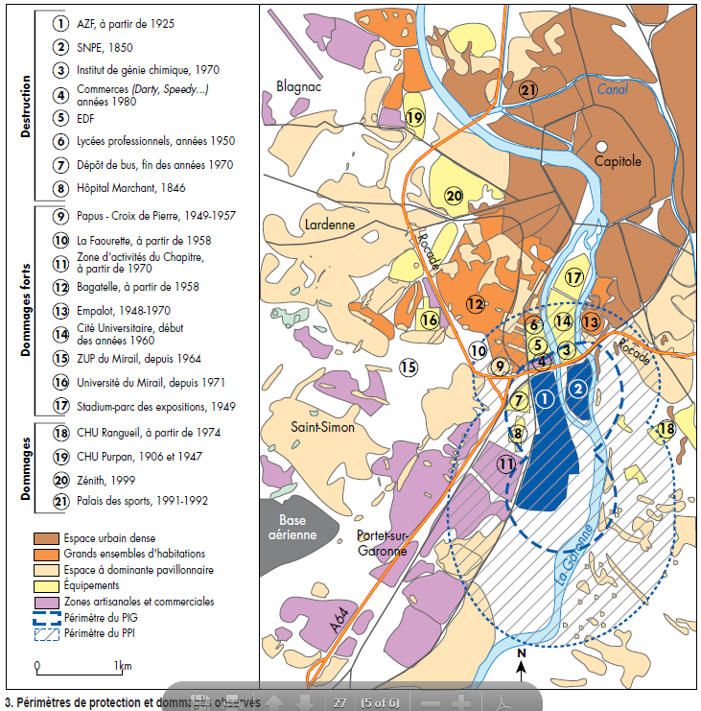
Source: L'explosion de l'usine AZF à Toulouse: une catastrophe inscrite dans la ville. Centre interdisciplinaire d'études urbaines (2002)

