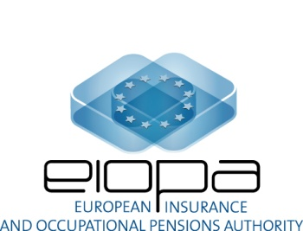

EIOPA REGULAR USE

EIOPA-CAT_WS-17/014
18 Aug 2017

EIOPA's catastrophe risk work stream (CAT WS) -
Draft agenda for 24/25 Aug 2017 meeting

Frankfurt am Main

24 May: 12.00 – 18.00 CEST

Lunch from 12:00

 | 12.45 – 13.00 | Draft agenda,  General announcements
 | 13.00 – 15.00 | NatCat recalibration: discussion of remaining topics for the recalibration process  - Finalisation of the process;  - Data collection process: NDAs and documentation/publication;  - Agreement on the timeline until final meeting in Sep 2017;  - Integration of contractual limits within the SF approach to SCR calculation (methodological constraints vs. understatement of SCR);  - Application of recalibration exercise for at least two scenarios (further documents to be circulated ahead of meeting).
 | 15.00 – 15.30 | Coffee break
 | 15.30 – 17.30 | NatCat recalibration continued
 | 17.30 – 18.00 | Motor vehicle liability risk sub-module / MTPL  - Outline of the envisaged proposal to the SCR review PG;  - Required input.

25 May: 09.00 – 14.00 CEST

Lunch from 12:00

 | 09.00 – 10.30 | Fire risk sub-module  - Progress of sub-work stream on fire risk since last discussion in June;  - Gross vs. net of reinsurance issue in fire, marine and aviation risk;  - Remaining work.
 | 10.30 – 12.00 | NatCat simplifications  - Update on simplifications document incl. calculations on the additional prudency options;  - Remaining work until final meeting in Sep 2017.
 | 12.00 – 12.30 | Lunch break
 | 12.30 – 13.45 | Collective update session on Man-made and Health Cat risk issues  - Simplifying mass accident  - Simplifying accident concentration  - Clarifying the “benefits payable” for the mass accident and pandemic risks  - Marine risk
 | 13.45 – 14.00 | AoB, closing remarks

