ARC Meeting 26/06/2019
High level recap of industry position

IFRS 17 position

- The insurance industry supports the goals of the International Financial Reporting Standards (IFRS) defined by the International Accounting Standards Board (IASB), which are to achieve high quality global accounting standards that provide meaningful, consistent and reliable financial reporting.
- Financial reporting is particularly important for the insurance industry, which is both a preparer and a user of reports. As preparers, insurers see an impact from IFRS on their products and investments. IFRS can also impact the cost and availability of the capital used to cover the high levels of solvency that help ensure companies remain strong and safe. And insurers are significant users of financial reporting, relying on financial information for their investment activities. Indeed, the European insurance industry is the region’s largest institutional investor, with over €10 200bn of assets under management.
- Since 2005, European regulation has required IFRS for consolidated reporting for all insurers that have shares or bonds listed on regulated exchange markets. However, significantly more insurers are affected by IFRS across Europe because many countries have opted to permit or require all companies, including unlisted insurers of any size, to apply IFRS. In fact, IFRS is mandatory for unlisted companies’ consolidated financial statements in over half the countries in the EU (see chart on p22). European insurers remain committed to the development of high-quality standards which improve their financial reporting. They have made significant contributions to the development of International Financial Reporting Standards (IFRS) 17 - insurance contracts - and are engaging significant efforts and considerable resources into its implementation.
- Insurers’ extensive testing coordinated by the European Financial Reporting Advisory Group (EFRAG) in the summer of 2018 as part of its endorsement work on IFRS 17 in the EU, along with their ongoing implementation projects, have provided significant new information and substantiated evidence since IFRS 17 was published. This identified the need for more time and for improvements to the standard to address significant issues in 11 areas because of their impact on meaningful reporting and their operational and implementation challenges. EFRAG wrote to the IASB highlighting six of these areas as meriting further consideration by the IASB.
- Insurance Europe and many associations outside Europe called for the standard to be reopened and the application date to be delayed by two years to allow time for the IASB to make the necessary improvements to the standard and to allow time for the wide range of insurers that are affected to implement the standard. In October 2018, the CFO Forum[1] proposed solutions[2] for the 11 areas of concern.
- European insurers remain committed to the development of high-quality standards which improve their financial reporting. They have made significant contributions to the development of International Financial Reporting Standards (IFRS) 17 - insurance contracts - and are engaging significant efforts and considerable resources into its implementation.
- Insurers’ extensive testing coordinated by the European Financial Reporting Advisory Group (EFRAG) in the summer of 2018 as part of its endorsement work on IFRS 17 in the EU, along with their ongoing implementation projects, have provided significant new information and substantiated evidence since IFRS 17 was published. This identified the need for more time and for improvements to the standard to address significant issues in 11 areas because of their impact on meaningful reporting and their operational and implementation challenges. EFRAG wrote to the IASB highlighting six of these areas as meriting further consideration by the IASB.

[1] The European Insurance CFO Forum (‘CFO Forum’) is a high-level discussion group formed and attended by the Chief Financial Officers of 23 major European listed, and some non-listed, insurance companies.
[2] http://www.cfoforum.eu/letters/CFO-Forum-letter-sent-to-EFRAG-and-IASB-o...

- Insurance Europe and many associations outside Europe called for the standard to be reopened and the application date to be delayed by two years to allow time for the IASB to make the necessary improvements to the standard and to allow time for the wide range of insurers that are affected to implement the standard. In October 2018, the CFO Forum[1] proposed solutions[2] for the 11 areas of concern.
- The industry therefore welcomed the International Accounting Standards Board's (IASB) decision in October 2018 to consider reopening the standard and explore potential areas of improvements to IFRS 17, including the issues raised by the industry. The IASB also decided in November 2018 to consider a one-year delay in the standard’s effective date.
- European insurers recognise the considerable work done by the IASB to date in its assessment of the issues. However, an assessment of the proposed amendments in a presentation[3] by the CFO Forum to the EFRAG technical expert group on 21 March shows that, while some helpful improvements have been proposed by the IASB, many of the issues remain unaddressed.
- European Insurers understand that the process is increasingly focussing on a compromise solution that would focus on a smaller subset of the current issues. Insurance Europe, together with the CFO Forum selected a subset 3 key issues that should be the focus of the discussions in finalising the Exposure Draft. However, the Insurance Europe compromise position on timing remains to seek a two-year delay in application of the standard.
- Insurance Europe remains committed to the IASB’s process for finalising IFRS 17 and is looking forward to the IASB’s upcoming exposure draft and working constructively so that IFRS 17 can achieve its objectives.

Summary of principal impact if issues identified within the current draft of IFRS 17 remain unresolved

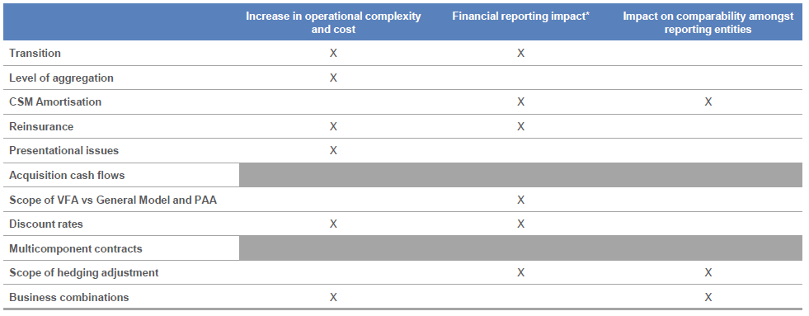

[1] The European Insurance CFO Forum (‘CFO Forum’) is a high-level discussion group formed and attended by the Chief Financial Officers of 23 major European listed, and some non-listed, insurance companies.
[2] http://www.cfoforum.eu/letters/CFO-Forum-letter-sent-to-EFRAG-and-IASB-o...
[3] http://efrag.org/Assets/Download?assetUrl=%2Fsites%2Fwebpublishing%2FMee...

Sources

1. CFOF presentation in July 2018 (http://efrag.org/Assets/Download?assetUrl=%2Fsites%2Fwebpublishing%2FMeeting%20Documents%2F1709191140230908%2F08-01%20CFO%20Forum%20presentation%20-%20EFRAG%20case%20study%20findings%20-%203%20July%2018.pdf)
2. Insurance Europe Letters (6 Dec 2018 - https://extranet.insuranceeurope.eu/Financial%20Reporting%20Working%20Group/PublishedDocuments/ECO-FRG-18-184.pdf) and (16 Oct 2018 - https://extranet.insuranceeurope.eu/Financial%20Reporting%20Working%20Group/PublishedDocuments/ECO-FRG-18-150.pdf)
3. CFOF assessment of IASB proposed amendments (https://extranet.insuranceeurope.eu/Financial%20Reporting%20Working%20Group/PublishedDocuments/ECO-FRG-19-048.pdf)
4. IE website position on IFRS 17 (https://www.insuranceeurope.eu/ifrs-17-position)

