Background
EIOPA publishes the technical information related to risk-free interest rate (RFR) term structures for a wide range of currencies and the symmetric adjustment of the equity capital charge monthly. The latest technical documentation for the RFR which provides EIOPA’s methodology for calculation can be found here. The secretariat monitors EIOPA’s RFR curves published for the euro as well as the symmetric adjustment and provides below summary information for members (Source: EIOPA, Insurance Europe).

- RFR curves with VA (euro) as at the end of December 2020 vs previous curve
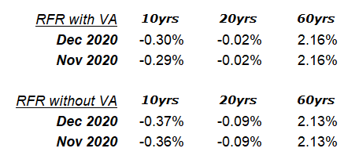
- Change in Volatility Adjustment and Credit Risk Adjustment
 | November | December
Volatility Adjustment (VA) (bps) | 7 | 7
Credit Risk Adjustment (bps) | 10 | 10

- Impact on discounting
The value after discounting a 1,000 euro cashflow at different years in the future is shown below along with the impact of changes in RFR (with VA) on these valuations:
 | 10yrs | 20yrs | 60yrs
Present Value using December 2020 RFR with VA | 1030 | 1005 | 277
Present Value change from November 2020 | 0.1% | 0.1% | -0.1%

- Symmetric Adjustment of the Equity Capital Charge
December 2020 | November 2020 | October 2020 | September 2020 | August 2020 | July 2020 | June 2020 | May 2020
-0.48% | -1.73% | -8.81% | -6.43% | -5.58% | -7.13% | -6.72% | -8.45%

