Summary

Solvency II came into force in January 2016 after many years of discussion. Insurance Europe supported, and continues to support, its primary objectives, namely a risk-based, harmonised European rule book for the insurance market which ensures a robust level of policyholder protection, a level playing field for all insurers and the ability for consumers to afford (new) insurance products. However, Insurance Europe has also consistently raised concerns about certain aspects of the design and calibration of the framework and, in particular, the treatment of long-term business (arising from both life and non-life).

One of the key aspects of Solvency II’s design regularly highlighted as being incorrect is the treatment of bonds and loans that are exposed to spread risk. The core assumption underlying the calculation of the capital requirements for those bond holdings (which usually are only corporate bonds) is that the insurer could be forced to sell them at any time and accept a price which is significantly lower than their current value. However, in reality, insurers, particularly those with long-term liabilities, plan their investments and liquidity needs carefully, often using sophisticated risk management techniques. The predictable nature of the liabilities combined with this investment approach means that the insurer can hold its corporate bonds to maturity. If it does sell them, it does so to optimise risk and returns. The insurer has limited risk of being a forced seller of these investments which allows them to avoid the risk of selling when prices are depressed

Although there is the possibility that some insurers may need to sell their investments at an inopportune time, this is not the reality for most insurers and should not be the core assumption underlying the capital requirement calculations.

Insurance Europe supports a change to the calculation of the capital requirements for corporate bonds in the Solvency II framework to better reflect the long-term nature and the business model of insurance business and proposes two approaches for further consideration:

- Introduce a counterparty default risk approach for corporate bonds risk which are not exposed to the risk of forced sale.
- Extend the dynamic volatility adjustment to the standard formula to allow all insurers to better reflect the credit risks within their portfolios.

In its recent Call for Advice on the 2020 Review of Solvency II, and in relation to its on-going Capital Markets Union project and objectives for removing barriers to investment and growth, the European Commission requested EIOPA to assess whether the methods, assumptions and standard parameters underlying the calculation of the standard formula market risk module appropriately reflect the long-term nature of the insurance business, in particular equity and spread risk.

Insurance Europe recognises the need to review the capital requirements for investments that support European growth and wants to emphasise the need to be ambitious in this work and to thoroughly investigate whether Solvency II appropriately measures the actual risks that insurers are exposed to when investing in corporate bonds (as well as other asset classes), and the possible loss of cash flows due to defaults or forced sales.

Insurance Europe supports the dynamic volatility adjustment as a key mechanism that permits companies using internal models to ensure the correct measurement of the real economic impact of credit/spread risk. Internal models work well in this respect, and therefore the focus of the 2020 Review needs to be on how to improve the standard formula treatment of credit risk.

Background

The EU’s Solvency II insurance regulation, which came into force in January 2016, is a ground-breaking, risk-based regulation that remains strongly supported by the European insurance industry.

From the outset, the insurance industry supported the core objectives of Solvency II because it wanted a modern, risk-based framework that:
- was consistent with the good risk management methods many insurers were already using;
- created a harmonised rulebook for Europe; and,
- ensured both fair competition and a consistently high level of policyholder protection across Europe.

Particularly welcome is Solvency II’s three-pillar approach, which recognises that internal governance, risk management and supervisory interaction (Pillar 2), along with supervisory and public disclosures (Pillar 3), are as important as capital requirements (Pillar 1).

During Solvency II’s development, the insurance industry highlighted a range of technical problems and, in particular, voiced major concerns about the treatment of long-term business and guaranteed products. In an attempt to fix this, a package of long-term guarantee measures was added to Solvency II in the “Omnibus II” Directive.

The industry made clear that these long-term guarantee measures were not sufficient to solve the problem but accepted that they could be improved in the two major review processes built into the Directive. At that time, Insurance Europe’s President, Sergio Balbinot, said “While the compromise reached between the institutions on Omnibus II is not the ideal solution the insurance industry would have wished for in terms of correctly reflecting insurers’ long-term business and low exposure to market volatility, we do believe it is a workable base from which to develop the technical details of the new regulatory regime.”

One of the key technical areas in which Insurance Europe raised concerns during the Omnibus II negotiations and continues to support further improvement is the capital requirements for corporate bonds and loans.

Insurer’s investment in corporate bonds

Corporate bonds and loans are important part of an insurer’s investment portfolio. At YE 2018, European insurers held 20.3%, or €2,200bn, of their aggregate investment portfolio in corporate bonds and XY% in loans.

Insurers make extensive use of corporate bonds and other fixed income instruments because they provide contractual payments which are known in advance. The fixed payments enable insurers to plan and match their cash inflows and outflows. The matching of cashflows in this way is part of a risk management strategy called asset-liability management (ALM) which is a practice widely used by insurers.

The ALM strategies used by insurers entail the (sophisticated) modelling of current and future investments to ensure that the investment returns and loans.are sufficient in both amount and timing to meet its expected future liabilities. Critically, as part of this approach the insurer will typically hold corporate bonds for a longer duration subject to risk management assessment and risk–return considerations.

Corporate bonds also often provide a higher yield than comparable government bonds or swaps to compensate the investor for the additional credit risk. The amount of additional yield available on a corporate bond is dependent on the credit worthiness of the issuer, the term to maturity of the bond and idiosyncratic features of the bond. The additional yield is known as the credit spread.

The insurer’s corporate bond portfolio therefore generates a higher return than if the insurer was investing solely in government bonds or cash. This enables the insurer to provide better returns pensions and other long-term savings products and reduce the cost of protection products for consumers. Insurers’ corporate bond portfolios can be well diversified thanks to the extensive and varied corporate bond markets prevalent across Europe.

The risks of corporate bond investment

As with any loan, the primary risk for the corporate bond investor (the lender) is the risk that the issuer (the borrower) will default on its obligations. If a default does occur, then the lender will, in most cases, receive less than the expected contractual payments. This is known as the default risk.

A secondary risk for corporate bond investors is the risk that they will be forced to sell the corporate bond for a price which is lower than they originally paid for it. For a bond not in default, a decrease in the market price of a bond normally arises due to either a change in market interest rates or a change in the market’s perception of the borrower’s ability to repay the bond, or a combination of these two events.

Interest rate risk is the term used to describe the risk of adverse price movements due to changes in prevailing market interest rates. It affects all the insurer’s fixed income investments as well as the value of its liabilities. It predominantly occurs because of changes in the macro-economic environment and is not directly related to the credit worthiness of the bond issuer. Solvency II deals with interest rate risk separately from credit and default risks. The treatment of interest rate risk is not in scope of this paper.

Spread risk is the term used to describe the risk of adverse price movements arising because of changes in the market’s perception of the borrower’s ability to repay the bond. This is because, if this risk materialises, the adverse change in the bond price alters the bond’s credit spread. As well as the market’s perception of the issuer’s creditworthiness, changes in credit spreads can materialise due to other factors such as reduced liquidity.

It is important to highlight that these secondary risks can only materialise where the insurer sells the bond at a loss prior to maturity. If the insurer holds the bond to maturity or until its value increases, it is only exposed to default risk. This is due to the reversal of unrealised losses in the bond portfolio up to the par value at their maturity.

Solvency II treatment of corporate bonds
For most insurers, the Solvency II capital requirement for corporate bond holdings is calculated based on spread risk. The core assumption underlying this calibration is that insurers will be forced to sell their bond portfolios at an inopportune time and incur a loss on the bond.

However, this assumption is contrary to reality. As noted previously, insurers use ALM strategies to plan their investments and extensively plan their liquidity needs to ensure that they are not exposed to the risk of having to sell all their corporate bonds at the same time, even during periods of market stress. For some insurers there may be a risk that they will have to sell some corporate bonds at an inopportune time, but this is the exception rather than the rule.

This incorrect assumption creates capital requirements for corporate bonds which are much larger than the losses that insurers would incur in the reality of an extreme market event. The additional capital requirements increase the cost of providing long-term insurance products for many insurers and markets. It also detracts from the risk-sensitive nature of the solvency framework as it does not adequately reflect an insurer’s risk management practices.

Indeed, Solvency II itself recognises this is an incorrect assumption for insurers who hold their assets to maturity.
- The standard formula capital requirement for an insurer’s investments in residential mortgage portfolios is calculated based predominantly on the default risk.
- Matching Adjustment (MA) portfolios are subject to a strict set of application criteria relating to the ALM practices of the insurers as well as the features of the products in the portfolio. Solvency II recognises that the insurer will hold the bonds in the MA portfolio to maturity and calculates the capital requirement for spread risk to reflect long-term nature of these investments.

In addition, insurers who use an internal model can benefit from a tool called the Dynamic Volatility Adjustment (DVA). This is a tool which permits the insurer to adjust the capital charge for its corporate bond portfolio in a similar way to the capital calculations for the Matching Adjustment portfolio. In December 2017, EIOPA published an Opinion on the use of DVA in internal models which but provided guidance on the modelling of a DVA and the risk management aspects of their use.

How should Solvency II be improved to better reflect the true risks of corporate bond investments?

Insurance Europe supports the investigation of two different approaches to resolving the incorrect treatment of corporate bonds within Solvency II. Both approaches already exist within the Solvency II framework in one form or another and could be easily implemented to ensure that the capital requirements for corporate bond exposures for all insurers are more reflective of the true economic risks.

The difference between the approaches emerges from their approach to the risk measurement of assets and liabilities. The first approach (the counterparty default risk approach) excludes those bonds not exposed to possible forced sales from a spread risk calculation based on pure changes of market values. The second approach (the dynamic volatility adjustment) does not change the risk measurement of the asset side but ensures that the total balance sheet approach of Solvency II is obeyed, ie that assumed spread changes are adequately reflected in the risk measurement of liabilities as well. To this end, the volatility adjustment, which is used for the liability valuation and is based on spreads, too, must be recalculated.

A counterparty default risk approach
As the name suggests, under a counterparty default risk approach, the capital requirement for corporate bonds is based on the default risk rather than spread risk, where bonds are not at risk of forced sale.
One way to implement the counterparty default risk approach would be as follows:
- Notionally separate the insurer’s corporate bond portfolio into two sections;
  - Section A: bonds which are not at risk of forced sales
  - Section B: bonds which are at risk of forced sales.
- Section A would be in scope of the counterparty default risk submodule. The capital requirement would be based solely on default risk.
- Section B would continue to be in scope of the spread risk submodule. The capital requirement for these assets would not change.
- The capital requirements for Section A and Section B would be combined as part of the wider SCR capital calculations to give an overall capital charge for credit risk.
Implementing a counterparty default risk approach for bonds which are not at material risk of forced sale would result in a treatment of corporate bonds which is consistent with the real economic risk faced by the insurer. However, this approach does require the identification of the assets that are not exposed to material risk of forced sale.

Extending the Dynamic Volatility Adjustment
To understand the rationale for and effect of a Dynamic Volatility Adjustment (DVA), it is necessary to revisit the volatility adjustment (VA) which is a measure that was introduced as part of the Omnibus II package to ensure the appropriate treatment of insurance products with long-term guarantees under Solvency II.

The VA is an adjustment to the risk-free discount rate used to calculate the value of the insurer’s liabilities. It is derived from the prevailing credit spreads of European insurers portfolios. As such, the size of the VA and therefore the value of the insurer’s liabilities are sensitive to changes in credit spreads.

For an insurer applying the VA, an increase in credit spreads should have two impacts: 1) a decrease in the value of the corporate bond portfolio and 2) a decrease in the value of the liabilities (due to an increased VA). From a balance sheet perspective, the decrease in the value of the assets is offset by the decrease in the value of the liabilities. Recognising and accounting for the impact on the value of the liabilities, as well as the assets, has the economically justified effect of reducing the impact on the insurer’s own funds and solvency position. It is also consistent with the standard formula calculations for interest rate and currency risk where the off-setting effects between assets and liabilities are modelled.

The standard formula capital requirements for spread risk are calculated using a scenario as the described; the impact on the insurer’s balance sheet of an increase in credit spreads. However, under the current formulation, insurers must assume that the VA remains constant; the increase in credit spreads is assumed to only apply to the assets. The assumption of a constant VA clearly results in an overstatement of the capital charge.

The DVA is a tool which enables insurers to model the impact of increased spreads on the VA in the stress scenario ie. to calculate the increase in the VA which would occur in the prescribed scenario. The value of the insurer’s liabilities is then recalculated using the increased VA and the decrease included in the spread risk capital requirements. A pre-requisite of the implementation of a DVA approach is that it should result in positive risk management outcomes and deter poor risk management.

The effect of the DVA could be enhanced even further if the VA calculation methodology is improved as part of the 2020 Review.

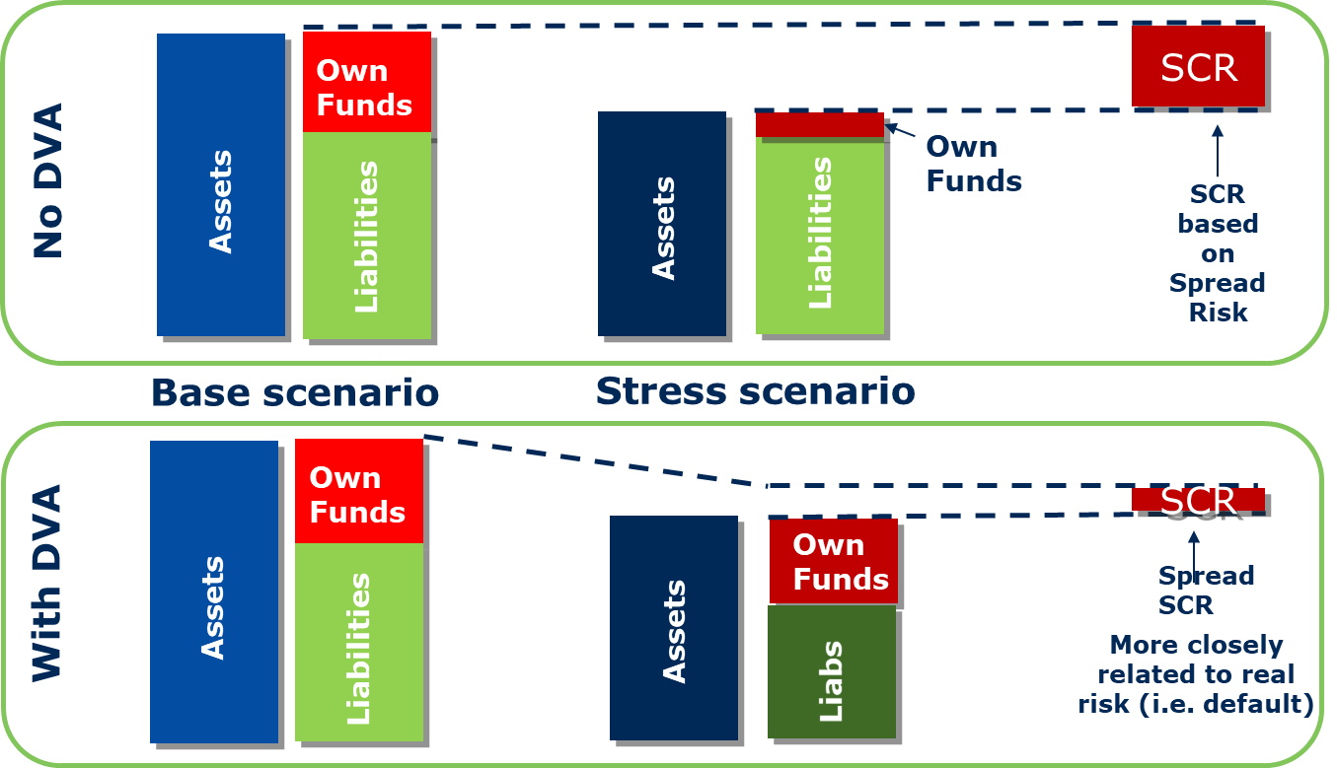
Operationally, the inclusion of a DVA into the standard formula should be a straightforward. As the EC already publishes the VA on a quarterly basis, it would add to this a publication of a DVA. Insurers would then simply calculate the difference in the value of their liabilities using the VA and DVA and subtract from the existing capital requirement for the assets.

In both the DVA and MA calculations, the insurer recognises the impact of the spread changes on both the assets and liabilities in its capital calculations. The inclusion of the impact on the value of liabilities in the capital calculation effectively transforms some of the spread risk into default risk. This is because the impact of changes in credit spreads on the value of the liabilities is typically the opposite of the impact on the assets.

Insurance Europe highlights that it does not support any changes to the scope or calibration of the spread risk submodule. It does not support the inclusion of capital charges for sovereign bond investments in the standard formula.

The 2020 Review of Solvency II

When finalising Solvency II back in 2013, policymakers realised the need to embed review provisions in the Solvency II framework, to ensure that clear opportunities were created to use the experience from Solvency II application, as well as the ever-changing economic environment to make the framework work as intended.

The EC has recently sent a Request for Advice to EIOPA on the 2020 Review of Solvency II. This requests EIOPA to investigate the treatment of corporate bonds in the standard formula and to assess whether the current treatment appropriately reflects the long-term nature of insurance business. It also requests EIOPA to investigate the modelling of the DVA by internal model users.

Insurance Europe recognises the need to review the capital requirements for investments that support European growth and wants to emphasise the need to be ambitious in this work and to thoroughly investigate whether Solvency II appropriately measures the actual risks that insurers are exposed to when investing in corporate bonds (as well as other asset classes).

Insurance Europe also supports the dynamic volatility adjustment as a key mechanism that permits the correct measurement of the real economic impact of credit/spread risk. The effect of the dynamic volatility adjustment could be enhanced by improving other aspects of the VA calculation methodology. It trusts that the Commission will investigate and test this claim and ask EIOPA to extend the dynamic volatility adjustment to standard formula users as one of the potential ways to address this deficiency in the framework.

Source: EIOPA
Spread risk in Solvency II implicitly includes downgrade and default risk
See Article 191 of Delegated Regulation for the requirements on the treatment of Mortgage Loans in the counterparty default risk submodule.
See Article 77b of Solvency II Directive
Opinion on the supervisory assessment of internal models including a dynamic volatility adjustment
Ceteris paribus

