Dear Ana Teresa,
Thank you for the opportunity to give feedback on the EIOPA Public consultation on Reporting and Disclosure. Due to the very short consultation period Insurance Europe was only able to provide limited feedback on the proposed amendments and further need for change which you will find in the lines below. These relate to annex 2 and 3 of the ITS on reporting (instructions regarding reporting templates for individual and group undertaking):

- S.01.01 – Content of the submission.
- The options provided for S.17.02, S.20.01, S.21.01, S.22.01, S.23.01 are not sufficient since those templates only have to be reported for direct insurance business. Hence, an option should be provided that these templates are “not reported as no direct insurance business exists”.

- S.06.02 – List of assets
- C0320/C0340
It is now required to enter “9” in C0340 if there is no external rating. However, what is the guidance if a standard formula firm has an internal rating that is used for its SCR calculation but is not a “9”? There appears to be a conflict here in the guidance between C0320 and C0340.

- C0320/C0350
Insurance Europe notes that EIOPA have added CIC category 8 to require ratings for these assets where applicable. For clarity, it would be useful to ensure that the wording is the same between these instructions. Currently they are not, as C0350 does not state “where applicable”. To avoid confusion and be consistent with other instructions in relation to CIC 8, the following wording should be added: “Regarding CIC 8 – Mortgages and Loans, other than mortgages and loans to natural persons”.

- C0330
Insurance Europe supports the introduction of a closed list for the ECAI. The previous requirement (name of ECAI as per ESMA website) was impractical, and a number of firms ignored the detail of this requirement and simply reported the “parent” agency.

- S.06.03 – Collective investment undertakings – look–through approach
Insurance Europe supports the intentions of EIOPA behind the amendments of S.06.03, as stated in the impact assessment by the following excerpts: “The proposed amendment aims to allow assessing the 90% considering the total amount of investments in Collective Investment Undertakings and not per fund.” “From a prudential perspective the relevance is in the total amount looked or not looked through. It makes sense that from the total CIU portfolio, 90% of the value is identified by country.”

However, the proposed amendments to the log file of S.06.03 are incomplete, and will not reach the intended goal of EIOPA (mentioned in the impact assessment) because the log file still requires that:
- The 5% limit per country remains applicable.
- It is still required that: “The look through shall be performed until the asset categories, countries and currencies are identified.”

The proposed wording should then further be adjusted in order to ensure that no look-through is necessary for funds with a non-material amount. This requires in our view inter alia to delete the sentences “all countries that represent more than 5 % of the funds being looked through” and “The look through shall be performed until the asset categories, countries and currencies are identified.”

- S.11.01 – Assets held as collateral
In Insurance Europe’s view the reporting requirements concerning mortgages and loans to natural persons are misleading an inconsistent, especially in comparison to the requirements in S.06.02. Following the general comments on S.06.02, mortgages and loans to natural persons (CIC 8) must be reported summarised in one position as those assets are not required to be individualised. This prompts the following remarks:
- There is no such general comment on S.11.01. However, the instructions for several columns in S.11.01 refer to the fact that mortgages and loans to natural persons, are not required to be individualized. Therefore, it remains unclear how mortgages and loans to natural persons have to be reported in S.11.01 and clarification is sought in this regard.

- If mortgages and loans to natural persons are not required to be individualized and have to be reported as a total figure then the collateral taken for these mortgage, mainly real estate, shall only be reported as a total figure in one line in S.11.01 as well.

- This should be clarified in the general comments on S.11.01.

- S.14.01 – Life obligations analysis
- C0010
Where the same product code appears in multiple rows, the current approach makes it possible to see what the different versions of the code represent. For example, in the Portfolio section, the split by country and by fund gives a clear distinction between the different rows. Insurance Europe does not believe that this change will add value through clearer information, and note that it also requires effort to implement and maintain that would otherwise not be required.

- C0040
Insurance Europe has reservations about the proposed change in respect of unbundled policy counts. For example, consider a pensions contract with a protection rider. The current treatment would be to unbundle the premiums, claims, expenses, charges etc., and ensure that these are allocated to correct lines of business, HRGs and product codes. Firms do not count two separate policies, however, as it is one contract and the rider component cannot exist in isolation without the underlying pension. It is potentially misleading to count two different policies in this situation, and Insurance Europe believes the correct presentation is to show the count associated with the main policy but not to show a second policy count for the rider (i.e. show one policy, not two).

- S.21.01 – Loss distribution risk profile
Insurance Europe is broadly satisfied with this change. However, the risk of negative numbers (which are not envisaged by the QRT) still exists, as there might be subrogation to consider. EIOPA has previously dismissed such a possibility; however, it needs to provide guidance on how to deal with it.

- S.22.01 – Impact of long term guarantees measures and transitionals
- C0070
The following should be added at the end of the instructions: “and without the transitional on technical provisions”.

- S.22.05.01 – Overall calculation of the transitional on technical provisions
- R0020-R0040
These cells show the technical provisions before transitional (split TP as a whole, BEL and Risk Margin) that are in scope of the undertaking’s TMTP, at the reporting date. As these cells show the value at the reporting date, they will only include policies still in force at the reporting date. Such policies must also have been in force at the recalculation reference date, and hence the second paragraph in the instructions should be deleted. A recalculation of the TMTP would not impact these values.

- R0010 and R0050
These cells show Day 1 values of Solvency II and Solvency I technical provisions, respectively. Ignoring any limit and assuming no recalculation, these would be unchanged throughout the transitional period. The TMTP at the reporting date is then the difference between the Day 1 Solvency I & Solvency II technical provisions multiplied by the portion in R0060 (which reduces by 1/16th each year).
If a recalculation is performed, the proposed amendments would require that the amounts in these cells only include policies still in force at the recalculation reference date, valued at the reporting date. Insurance Europe believes it is the intention that these cells should only change when a recalculation is performed, and should then be unchanged until any further recalculation. Therefore, the reporting date is not relevant and we suggest that “at the reporting date” is deleted. Secondly, Insurance Europe believes that these cells must always represent a Day 1 value so that the runoff factor in R0060 can be applied. Where a recalculation is performed at a later date, the Solvency I and Solvency II technical provisions calculated at the recalculation reference date (and limited to business in scope of the transitional) would need to be “grossed up” to a Day 1 value before the runoff portion is applied. The following worked examples show how a recalculation may affect the TMTP under the proposed changes and an alternative approach that is more in line with how Insurance Europe thinks the TMTP is intended to operate.

Firstly, assume that the only item affecting the TMTP is the Risk Margin, and the Risk Margin at Day 1 was 100 units and expected to reduce by 8% per annum. The TMTP on Day 1 (time 0) is equal to the Risk Margin of 100 and will reduce by 1/16th of 100 each year, to zero after 16 years. If the business runs off exactly in line with expectations and the TMTP is recalculated each year, then the difference between the amounts shown in R0010 and R0050 will reduce each year. The portion in R0060 also reduces each year, so the resulting TMTP reduces for the business runoff and the reducing portion applied (this is referred to as “double runoff”). So, recalculating the TMTP means the TMTP moves away from the underlying Risk Margin, which seems undesirable. The following graph shows that this can have a very significant effect on the value of the TMTP:
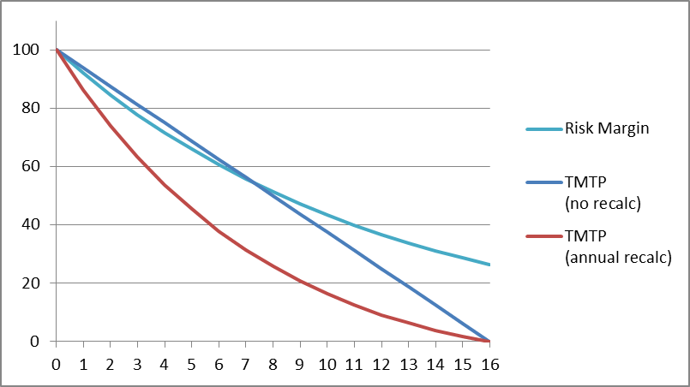

Now assume that the Risk Margin increases by 20% after 4 years (say due to interest rate movements). The impact of a recalculation of TMTP is shown in the following graph, assuming double runoff or applying a method to avoid double runoff:
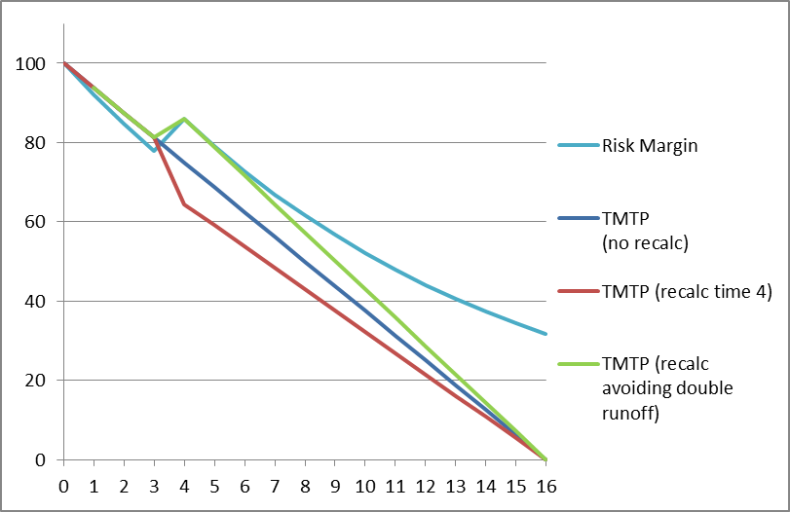

If double runoff is not avoided, a recalculation leads to the TMTP reducing when the underlying Risk Margin has increased. This is not the expected outcome – a recalculation should help ensure the TMTP remains in line with the underlying risk profile of the business, not move it further away.
- R0070
The proposed instructions require R0070 to be set to the same amount as R0060 if no limitation is applied to the TMTP. R0060 contains the portion applied in the TMTP calculation and takes values between 1 and 0. If R0070 is to show the TMTP at the reporting date, this should be {R0060}*({R0010}-{R0050}).

- S.29.04 - Detailed analysis per period – Technical flows versus Technical provisions
In Z0010 a closed list is provided for the lines of business. According to this instruction, health insurance (LoB 29) and annuities stemming from non-life insurance contracts and relating to health insurance obligations (LoB 33) shall be included in LoB 37 (Life). On the other side life reinsurance (LoB 36) shall be included in LoB 38 (Health SLT). These prompts the following remarks:
- This is inconsistent with the approach in other templates, e. g. S.12.01, especially the allocation of life reinsurance in LoB 38 (Health SLT) is misleading.
- The allocation should be consistent across all templates and therefore aligned.

