Risk Margin

Industry key views
- There are widely acknowledged issues with the design and calibration of the current risk margin.
- Insurance Europe supports the intentions of the co-legislators to address these issues through a 4.75% Cost of Capital and the introduction of an appropriate exponential and time dependent element (lambda parameter).
- Industry supports a calibration of the lambda parameter of 92.5%, without a floor. This would achieve the objective of roughly halving the size and volatility of the risk margin consistent with the technical evidence and political ambition.
- In addition, there should be appropriate recognition of diversification of risks at group level.

Background
The risk margin is part of an insurer’s liabilities (known as “technical provisions”) on the Solvency II balance sheet. It is an additional buffer held by insurers, above the best estimate which is expected to be required to pay all customers’ claims and benefits, including administration costs.
Its theoretical prudential purpose is to ensure that, in the rare event of an insurer's failure, sufficient funds are available to transfer the insurer’s liabilities to a third party, such as another insurer, thereby enabling an orderly run-off of the portfolio.
Issues with the current risk margin approach
The issues with the risk margin are:
1) it is very excessively calibrated,
2) it penalises long-term products and
3) it introduces excessive volatility.
The risk margin, amounting to €141Bn for the industry, is significantly higher than necessary. This is because the risk margin, and in particular the Cost of Capital parameter, were not correctly calibrated when the Solvency II Directive was being developed.
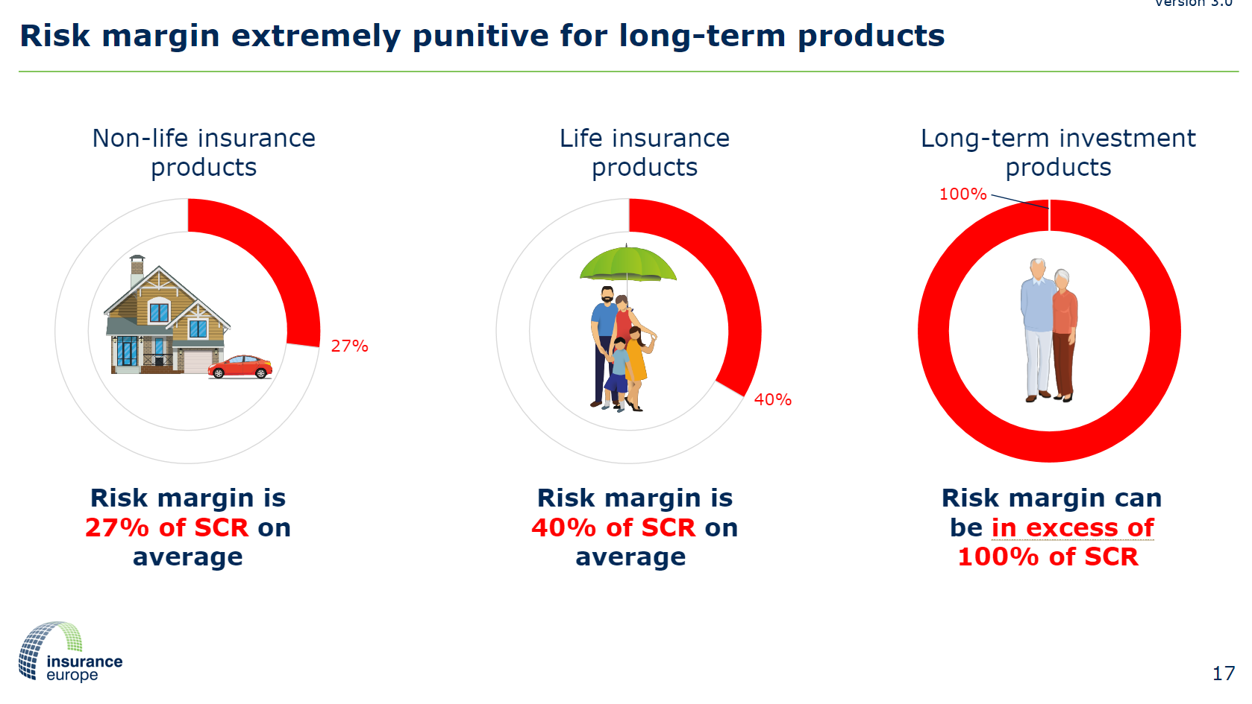
The current methodology also introduces unnecessary volatility to solvency positions by placing too much emphasis on the very long-term projections.
This excessive level and additional volatility introduced reduce insurers’ own funds and limits their risk and investment capacity.
Proposed reforms
In their agreed revisions to the Solvency II Directive, the co-legislators recognised the issues outlined above and noted their intention to reduce the burden of the risk margin.
To address these issues, the co-legislators agreed to set the Cost of Capital rate at 4.75%. This is a key change, fully supported by industry, that alleviates some of the excessive capital requirements.
The co-legislators also strongly supported changes to design of the risk margin to address the punitive treatment of long-term business and to address the excessive volatility. This is noted in recital 33a which states that:
“In addition, the calculation of the risk margin should account for the time dependency of risks and reduce the amount of the risk margin in particular for long-term liabilities. This would reduce the sensitivity of the risk margin to interest rate changes. An exponential and time dependent element should be introduced to implement this adjustment”
To achieve the co-legislators stated intentions and deliver the necessary improvements, the calibration of the exponential and time-dependent element (known as the lambda parameter) is critical.
Calibrating the lambda parameter
Insurance Europe has previously evidenced why a reduction in the risk margin of at least 50% is justified (see here).
As such, Insurance Europe fully supports setting the lambda parameter to a level which would reduce, in conjunction with the 4.75% Cost of Capital, the size and volatility of the risk margin by 50% from current levels.
Concretely, this means the lambda parameter should be set to 92.5% without a floor.
It is worthwhile highlighting that other prudential regimes either do not apply a risk margin or have a significantly lower risk margin than that in Solvency II. For example, in the UK, the PRA has provided support to the 70% reduction of the risk margin for long-term business through a reduced cost of capital and 0.9 lambda.
CHART SHOWING RISK MARGIN REQUIREMENTS IN VARIOUS JURISDICTIONS – TO BE INCLUDED
Other improvements
In addition, counter-intuitively, diversification between risks at group level is not permitted when calculating the risk margin. This contrasts with other areas of the Solvency II regulation (SCR, risk margin at solo level) and practical experience – where there are many examples where groups have transferred policies as a whole.
By not allowing for diversification between different entities within a group, the current approach to calculating the risk margin has the effect of artificially increasing the projected SCRs at group-level and hence leads to an overinflated risk margin.
To address this shortcoming, the arbitrary separation of obligations should be removed, and the risk margin methodology should be amended to allow for diversification between lines of business within a composite undertaking and legal entities within a group, for example by changing the Delegated Regulation as set out in the annex.

Annex – proposed amendments needed to address the diversification

- deleting Art. 38.1(b) of the DA and
- by replacing Art. 336 of the DA with: Method 1: Risk Margin
The consolidated risk margin of technical provisions on the basis of the consolidated data shall be calculated as the sum of the following:
(a) a risk margin calculated on the basis of consolidated data referred to in Article 335(1)(a), (b) and (c) of this Regulation following the rules laid down in Title I, Chapter VI, Section 4 of Directive 2009/138/EC;
(b) the proportional share of the risk margin of each undertaking referred to in Article 335(1)(d) of this Regulation; for a related third-country insurance or reinsurance undertaking which is not a subsidiary the risk margin shall be calculated as if that undertaking had its head office in the Union.
The replacement of Art. 336 of the DA in the proposed manner would lead solely to a change in the calculation technique for the risk margin on Group level, but have no consequences (e.g. in terms of reallocation) to the calculation on legal entity level, thus ensuring the same level of policyholder protection

EIOPA Annual Solo statistics 2022

